- Getting Started with MSI
VPN (necessary to work off campus)
Set up Windows native VPN as described [https://it.umn.edu/services-technologies/virtual-private-network-vpn?km=]
(Recommended, PC only) Notepad++
[https://notepad-plus-plus.org/] Like notepad, but useful. Also can do column selection – very useful.
WinSCP (PC only)
Download and install WinSCP [https://winscp.net/eng/docs/guide_install] and PuTTY [https://www.chiark.greenend.org.uk/~sgtatham/putty/latest.html].
Host name: mangi.msi.umn.edu
User name: x500 (e.g. cmstaley)
Password: password
Click ‘Advanced’
Select Tunnel and check “Connect through SSH tunnel”
Re-enter the above information.
The first time you log in, you have to click “yes” a few times.

Filezilla (for Mac)
[https://www.msi.umn.edu/support/faq/how-do-i-use-filezilla-transfer-data]

WinSCP operation (similar on FileZilla)
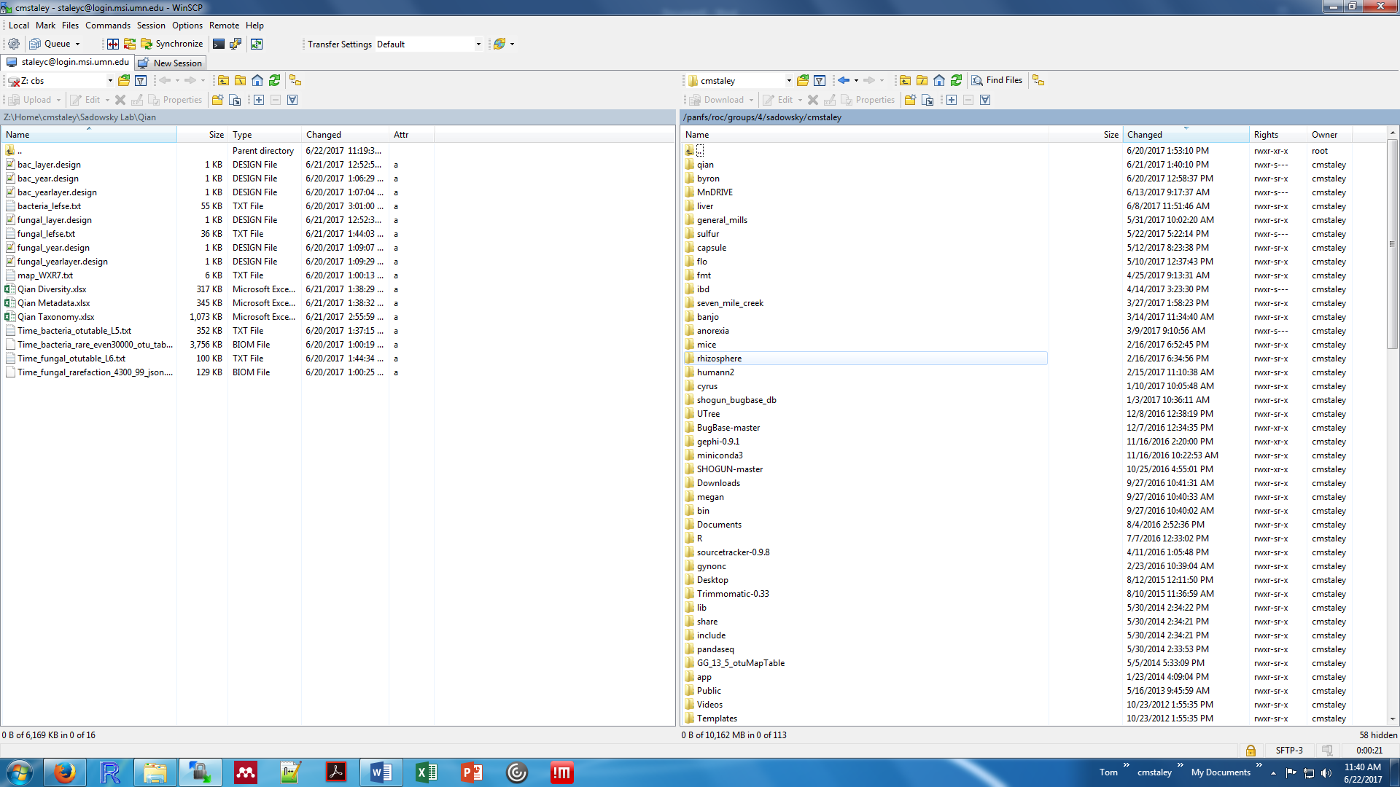
D
C
B
A
- Local directory (your computer)
- MSI directory
- Current location
- Click to open a new directory
Any data stored on your home directory (/panfs/roc/groups/8/cmstaley/) counts against the collective group space, which is limited and provided by specific request. For temporary processing, navigate to /panfs/roc/scratch/ and create your own directory there. This is free space to use for processing. Transfer anything you want to keep back to the home directory.
PuTTY (PC only)
To actually work on the supercomputers, open PuTTY (ctrl + P or ‘Open in PuTTY’ under Commands).
Terminal (Mac only; part of the default computer software)
You will start at a prompt ($ means prompt, do not type it):
$ ssh -Y username@mangi.msi.umn.edu
Once logged in…
You start in your home folder in your default group. See below for operational commands.
Basic commands:
$ cd /path/to/directory/ Changes directory
$ mkdir Create directory
$ cp filename1.ext filename2.ext Changes a filename without deleting original
$ cp file1.ext /new/directory/file1.ext Copies file to a new directory
$ mv filename1.ext filename2.ext Changes a filename deleting original
$ mv file1.ext /new/drectory/file1.ext Moves a file to a new directory
$ ls List all files in a directory

Most software is available as modules.
To access R:
$ module load R
$ R

To access mothur:
$ module load mothur/1.41.1 (The default is ver. 1.33.3, which is really buggy)
$ mothur

To view all software, first search of MSI website. To see which versions are available

$ module avail module

There are default resources on all the computers e.g., a job will get killed if a single command takes more than 20 min or exceeds 8 gb on the lab servers. Additional info here [https://www.msi.umn.edu/queues]. To request additional resources once logged onto a server:
srun -N 1 --ntasks-per-node=4 --mem-per-cpu=1gb -t 12:00:00 -p interactive --pty bash
Job files
Submitting a non-interactive job requires a job file. This file should be written in Notepad, switch ‘save as type’ to ‘all files’ and save the file as name.job. The job file looks like:
#!/bin/bash -l
#SBATCH --time=96:00:00
#SBATCH --ntasks=4
#SBATCH --mem=24g
#SBATCH --mail-type=ALL
#SBATCH --mail-user=cmstaley@umn.edu
cd /panfs/roc/scratch/cmstaley/
module load mothur/1.41.1
mothur data.batch

